Press Release (download at www.international-foundry-forum.org)

Digitalisation, additive manufacturing and new mobility:

castings shaping future

Dresden/Düsseldorf/Frankfurt, September 26, 2016

“Foundries sell solutions for the products of their customers” states Filipe Villas-Boas, President of the CAEF Executive Committee. More than 250 CEOs of the world’s leading foundries and their suppliers from the mechanical engineering and foundry chemical products industry discussed with representatives of the main casting purchasers about current industry trends, challenges and future expectations at the ninth International Foundry Forum in Dresden on September 23-24, 2016.

The IFF is jointly organised by CAEF (The European Foundry Association) and CEMAFON (The European Foundry Equipment Suppliers Association).

The programme of this main event of the foundry world dealt with the major challenges and opportunities of the sector. Even though there will be a change both of markets and regions as well as in materials and products, the need for castings will constantly grow in the future.

Additive manufacturing techniques and the digitalisation will be necessary changes the foundry industry has to implement in order to remain a successful supplying industry. The massive collection of data and the automated analysis in combination with the use of e.g. additive manufacturing in well-defined situations are key factors to success. Today, these technologies are an integrated part of the foundry business.

As to the main customer of foundries, the automotive industry, an insight into the future of mobility was given by Rolf Hattler, BMW. He stated that environment and climate regulations as well as urbanisation are driving forces for e-mobility. Nevertheless, novel power train concepts will still be combined with combustion technology for the years to come. “Thus, castings have a future”, he says.

A look into the future of the foundry industry was given by Reiner Kurtz. He introduced his Smart Foundry. In order to increase productivity and improve lead times the presented innovative logistic process is using self-driving devices for internal transport among others measures.

Summing up, Dr. Ioannis Ioannidis, Acting President of CEMAFON, stated that in spite of the current problems of the industry the sector can have an optimistic view of the future if innovative solutions continue being implemented. “It´s up to us to shape the future”, he says.

Photos (© LarsNeumann.Fotografie)
More than 250 CEOs met at the ninth International Foundry Forum
Opening speech of Mr. Villas-Boas, CAEF
Opening speech of Dr. Ioannidis, CEMAFON
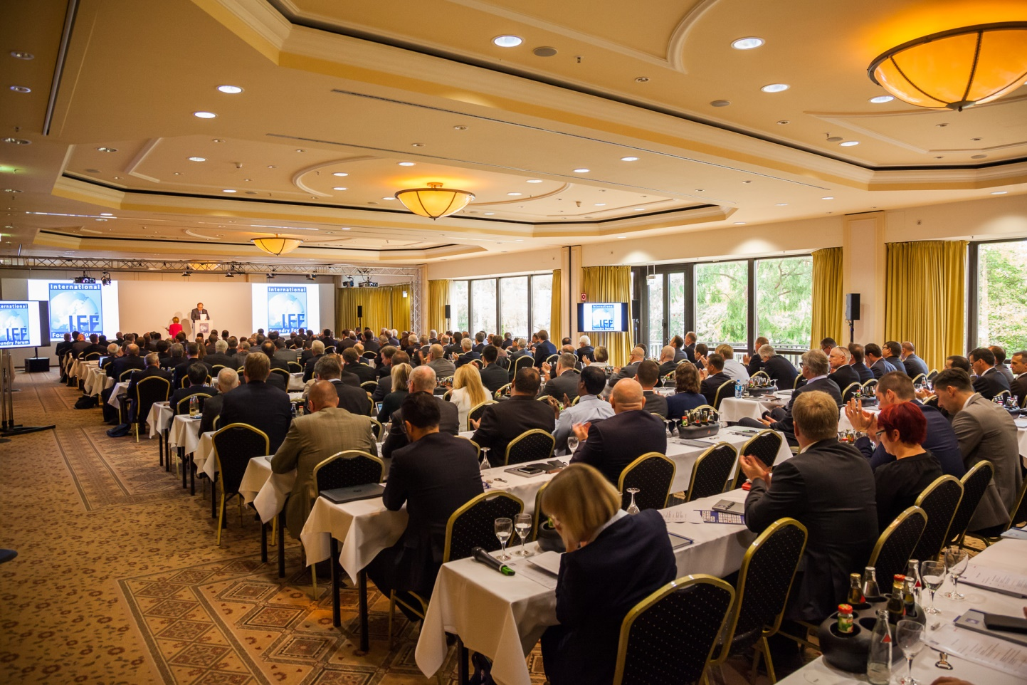

More than 250 CEOs met at the ninth International Foundry Forum (© LarsNeumann.Fotografie)

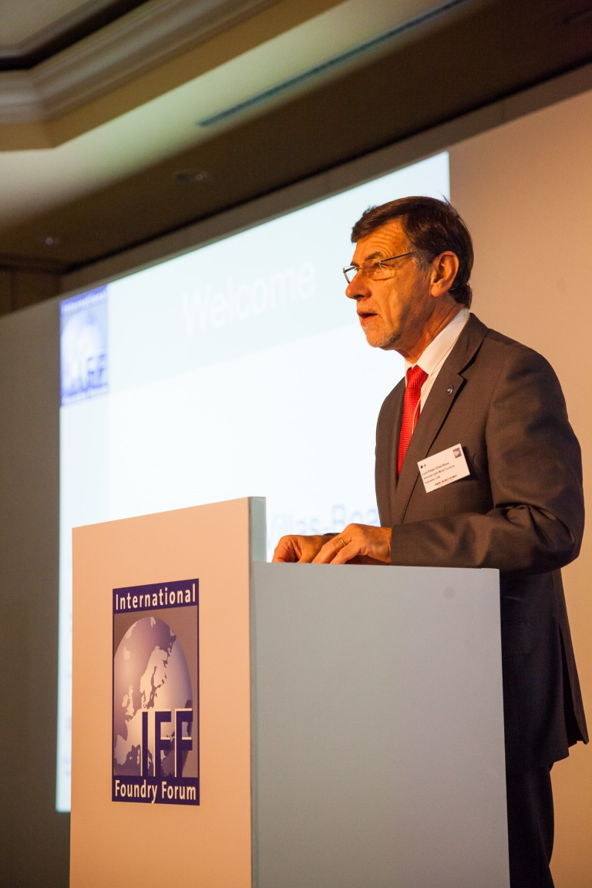
Opening speech of Mr. Villas-Boas, CAEF (© LarsNeumann.Fotografie)
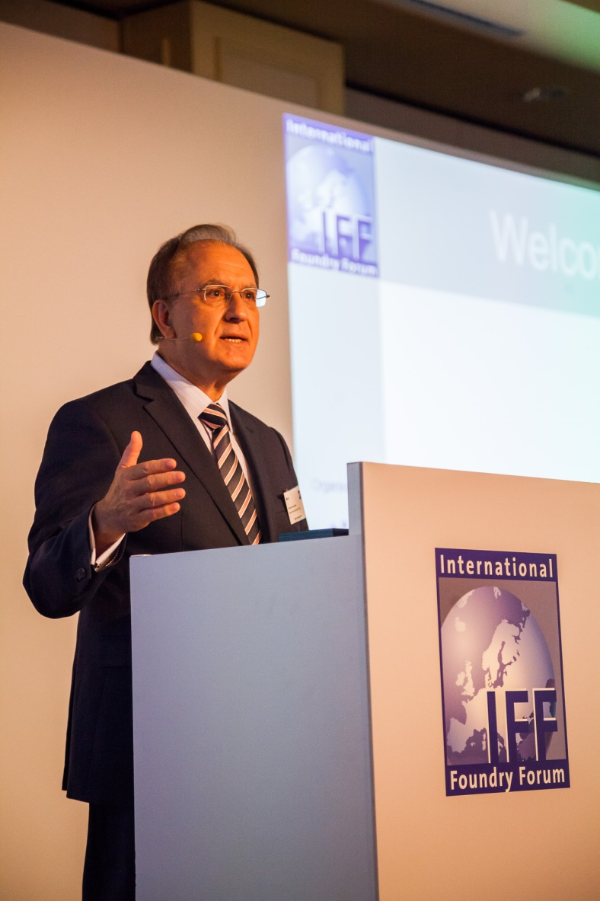
Opening speech of Dr Ioannidis, CEMAFON (© LarsNeumann.Fotografie)

Text and photos are ready for download at www.international-foundry-forum.org

Contact:
IFF
International Foundry Forum organised by
--------------------------------------------------------------------------------

CAEF - The European Foundry Association
Phone: +49 (0)2 11 / 68 71 - 217
Fax: +49(0)2 11 / 68 71 – 205
www.caef.eu
--------------------------------------------------------------------------------

CEMAFON - The European Foundry Equipment Suppliers Association
Phone: +49 (0)69 6603-1278
Fax: +49 (0) 69 6603-2278
www.cemafon.org
--------------------------------------------------------------------------------

E-Mail: info@international-foundry-forum.org

